August 27 th
Writing
Create a short poem about spring.
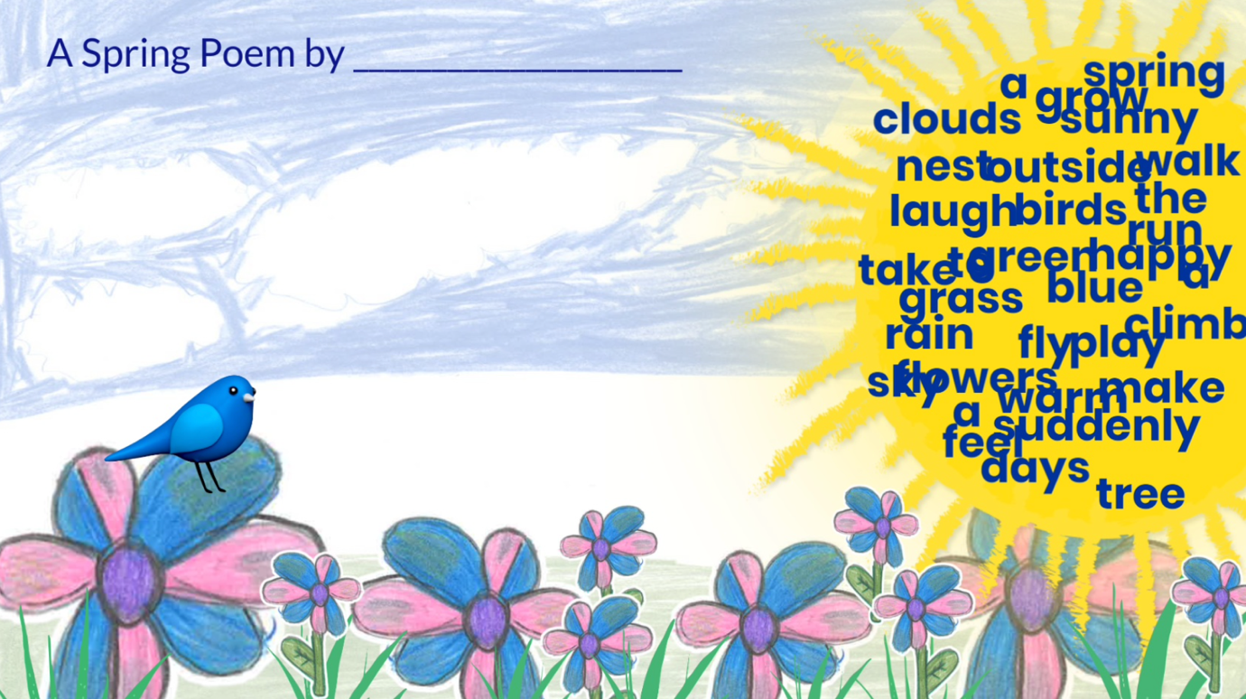

Phonics
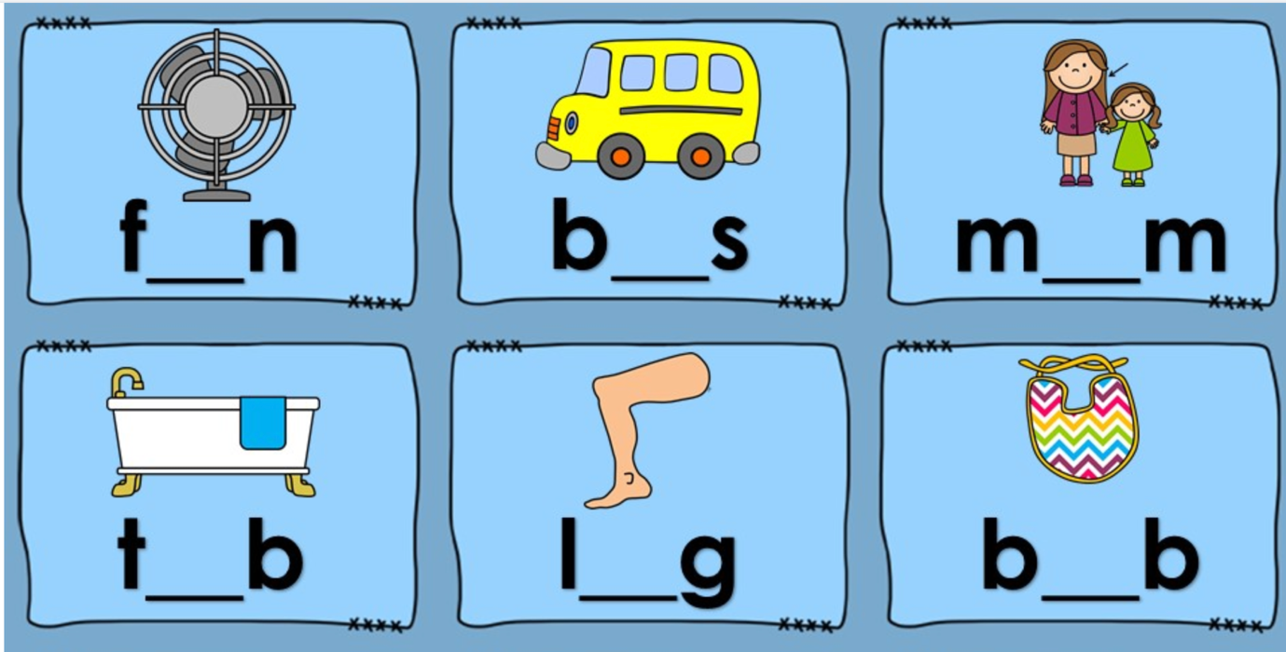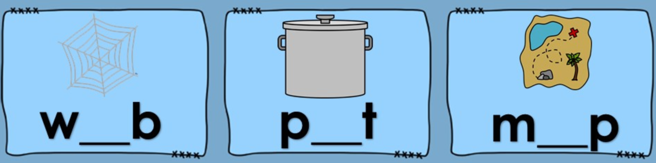

Story Time
I need a monster
https://storylineonline.net/books/i-need-my-monster/

Math
Count in hundreds, tens, and ones
e.g. 114=100+10+4

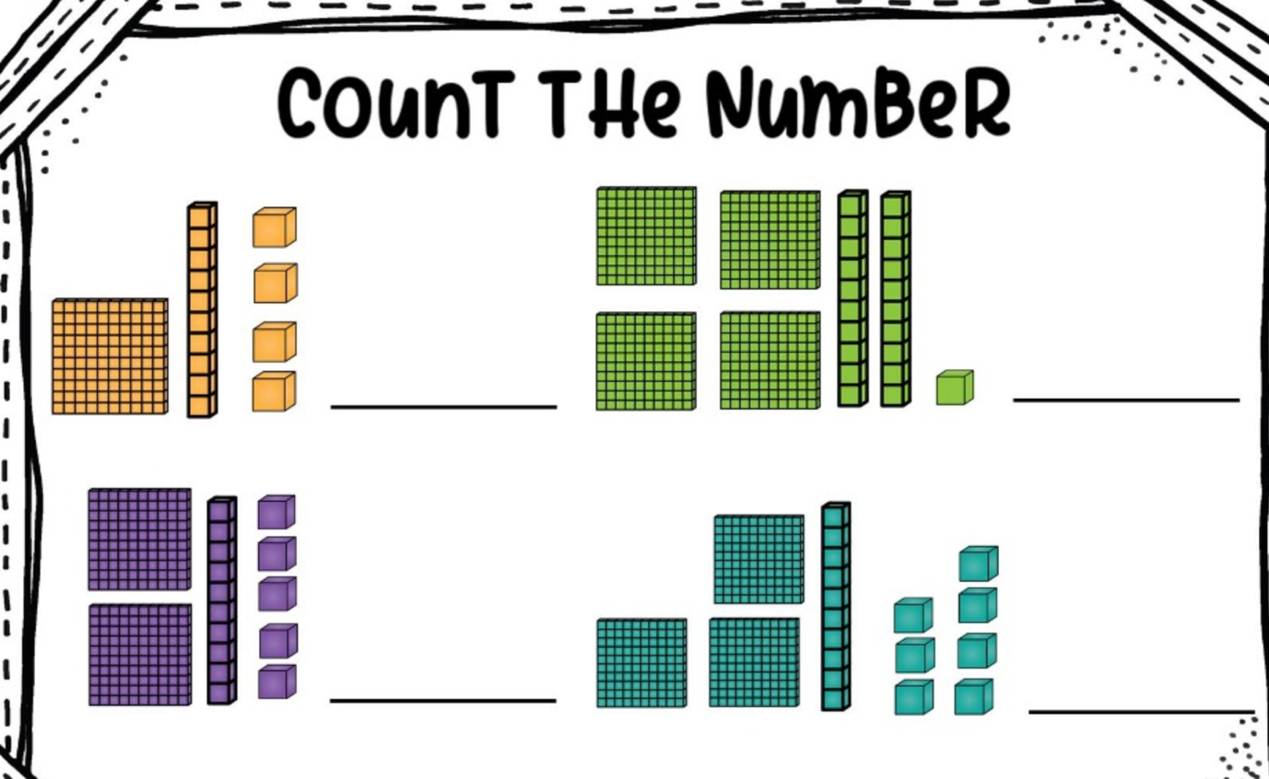

Science
Draw a flower and label parts of your plant.
