August 25 th
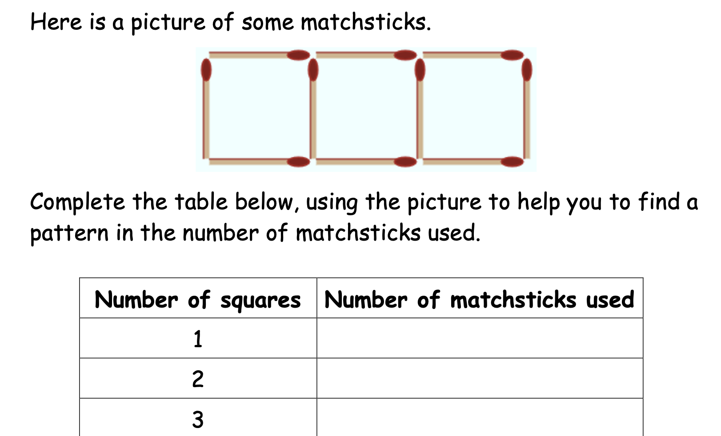

Dance in a bubble
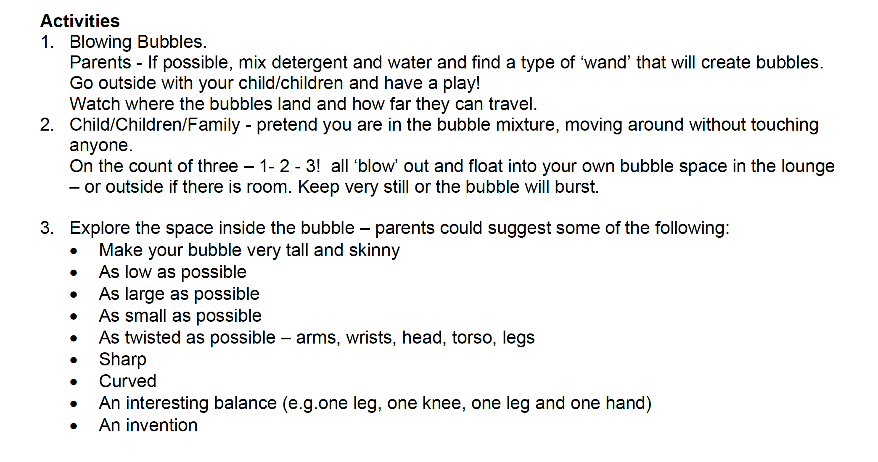

Reading
https://www.orsymphony.org/discover/watch-listen/symphony-storytime/?gclid=Cj0KCQjwsZKJBhC0ARIsAJ96n3WmnbqU-nY9jopeVzr-OyHHKKNwjpVC2BIZrJU6Mfgh2PPLB_D_XNEaAvp9EALw_wcB

When the moon is full

Just the beautiful flute sound and lyrical poems

