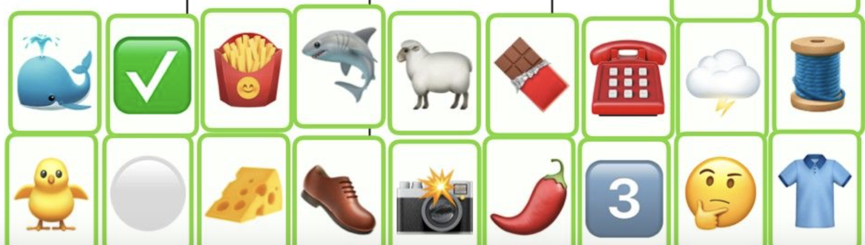
Spelling and phonics
Try to spell those words using your sound knowledge.
1.stretch the sound out
2. Hear the sound carefully
3.record the sound you hear in order

Maths
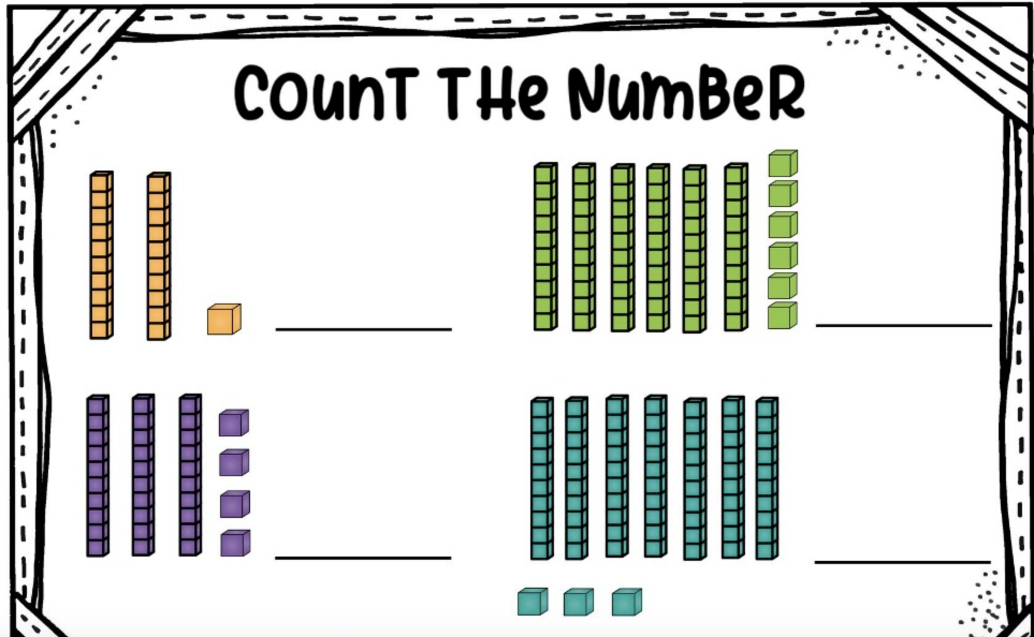
Count in tens and ones
E.g. 10,20,30,31,32,33,34
Filling in the middle sound
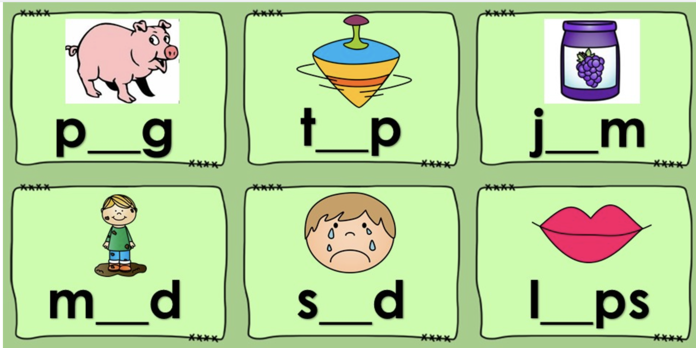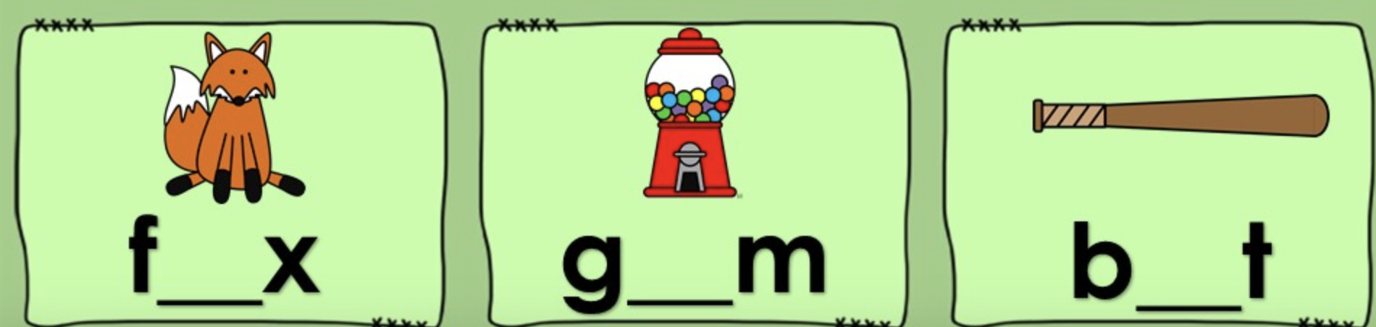

Reading:
https://www.myon.com/index.html
Username: name15 (e.g. jojo15)
Password: HendersonNorth

Explore your reading journey on Myon. There are thousands of ebooks writing for you!

Witing
Writing your sentences with details
E.g.

